Axis Metrology (3pages – page breaks for formatting reasons)

Renishaw Retrofit Products <h1>
For more than 30 years, Renishaw has been delivering innovative milestones in industrial metrology. From their original touch-trigger probes, repeatable stylus changing and modular scanning systems to their most recent development in 5-axis measurement technology. Renishaw’s dedication to research and development has proven them to be a consistent industry leader.

Retrofit vs. Buying a New CMM
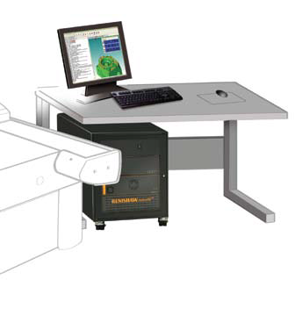
As most CMM structures are not subject to high levels of wear and tear, older CMMs remain serviceable for many years. The biggest change over the lifespan of your CMM will reside within software, control systems, and sensors. With Retrofit services, all of these items can be replaced and upgraded, consequently providing a CMM that works like new with the addition of new technologies outside of the CMM frame.
Purchasing a new CMM can become extremely costly, and because the CMM structure has not changed dramatically, often does not include enough benefits to justify the cost. If you are concerned with the status of your CMM, retrofit services should almost always be the first option.

Upgrading your CMM can give it a new lease of life:
- More Capability: With simple, fast and intuitive CAD-driven programming and graphical reports that are easier to interpret.
- More Throughput: Using the latest sensors and motion control techniques.
- More Profitability: Retrofitting your machine will reduce maintenance and support costs.
- More Information: Automated multi-sensor measurements allow you to gather more information about your parts.
- More Confidence: Peace of mind knowing that your CMM is equipped to meet your future measurement needs.

Renishaw UCC2 Universal Controller
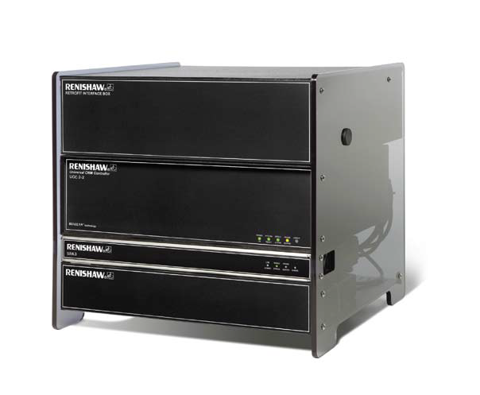Renishaw provides everything you need to transform the performance of your old CMMs. At the heart of Renishaw’s Retrofit Products is the UCC2 Universal CMM controller. When you combine the UCC2 controller with the Renishaw servo power amplifier, it enables your CMM to have precise motion control for up to 5 axes of simultaneous motion on machines of all sizes and includes support for rotary tables. Additionally, due to a single box interface to all of Renishaw’s sensors, it can gather surface data at up to 4,000 points per second.
Renishaw also utilizes an open format for their sophisticated machine error mapping, which allows their users the ability to perform their own recalibration and temperature compensation. Perhaps most important of all, the UCC2 Universal Controller complies with I++DME protocol, which allows its users the ability to have a wide selection of metrology software.

Key Features:
- I++DME Compliant (Most metrology software uses this protocol)
- Full support with all Renishaw Sensors
- Cost-Effective UCClite suitable for touch-trigger applications

PH20 – 5-Axis Touch Trigger Measurement
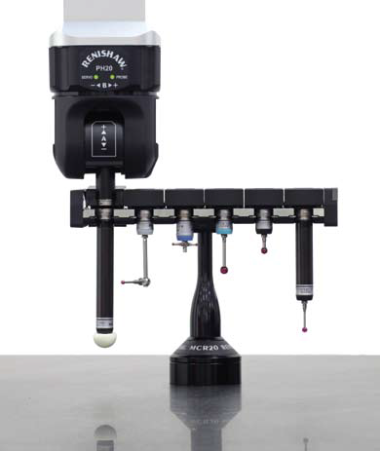
PH20’s unique design allows for ‘head touches’ to take measurement points by moving only the head rather than the CMM structure. This not only maintains the structural integrity of the CMM structure, it also integrates with Renishaw’s 5-axis motion technology, which eliminates time spent indexing the head.
Together, you can expect a significant increase in your throughput. In fact, typically throughput is increased 3-fold over conventional systems, due to the increased speeds in Renishaw’s technology.

Key Features:
- 5-axis simultaneous motion allows for larger parts to be measured on the CMM by minimizing the space required around the part for head rotation
- Index head compatibility – no requirement to modify existing programs in most cases.
- I++DME communication allows for a wide selection of metrology software
- Integral TP20 Probe – allows re-use of existing equipment (Link to: Renishaw retrofit 4.pdf)
- Compact Design – suitable for a wide range of CMMs using shank or quill mounting

See below for more retrofit resources:
- Probing & Styling – link to site page
- Fixturing – link to site page
- Software – link to site page
- Complete Renishaw Retrofit Brochure – PDF link

